|  |
| --- |
| Muscle Physiology Lab |
| MRI Muscle Experiment Set-up |
| Standard Operating Procedure |

|  |
| --- |
| Damon Lab  8-3-2015 |

# OVERVIEW

This manual describes the general steps needed to prepare for a MRI muscle experiment including how to set-up: the patient bed, the equipment outside of the MRI, the subject for the scan, and the force system for visual feedback. Additional steps and details may be needed for specific experiments.

# EQUIPMENT

Figures 1 and 2 show the equipment used for a typical MRI muscle experiment.

* Foot Exercise Device (FED)
* Force System Box
* Force System Extension Cable
* Laptop with Labview Force Program
* Patient Bed
* Foam Positioning Pads
* Timer – only used if contraction duration is needed (e.g. dynamic scans)

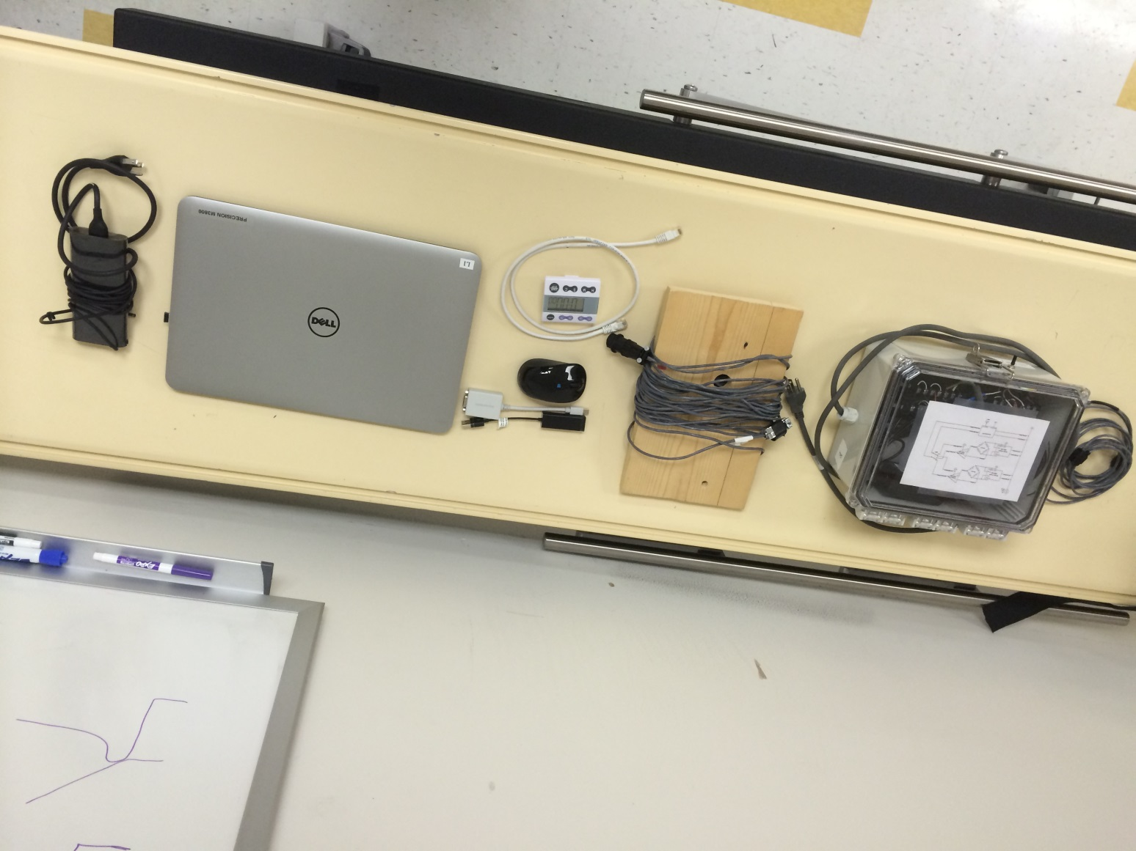

Timer

VGA to Mini Display Port

Ethernet to USB

Mouse

Force Box

Ethernet Cable

Extension Cable

Laptop

Power Adapter

**Figure 1: MRI Muscle Experiment Equipment. *Indicates a component that is recommended for a data collection session but is not essential.**

Force Box – Powers force system, collect and sends signal

Extension Cable – Connects force box to force transducer

Ethernet Cable* – Can be used to connect NI chassis directly to laptop if WiFi signal is poor

Timer* – Used for manual time keeping in addition or in place of timer VIs

Laptop – Runs force system via LabView

Power Adapter* – Provides back up power to laptop

Mini Display Port to VGA* – Adapts VGA to Mini Display (laptop does not have VGA)

USB to Ethernet* – Adapts Ethernet to USB (laptop does not have Ethernet port), this is only needed if you use Ethernet to connect to force system

Mouse* – Allows better dexterity within program, helpful when stopping/starting program often

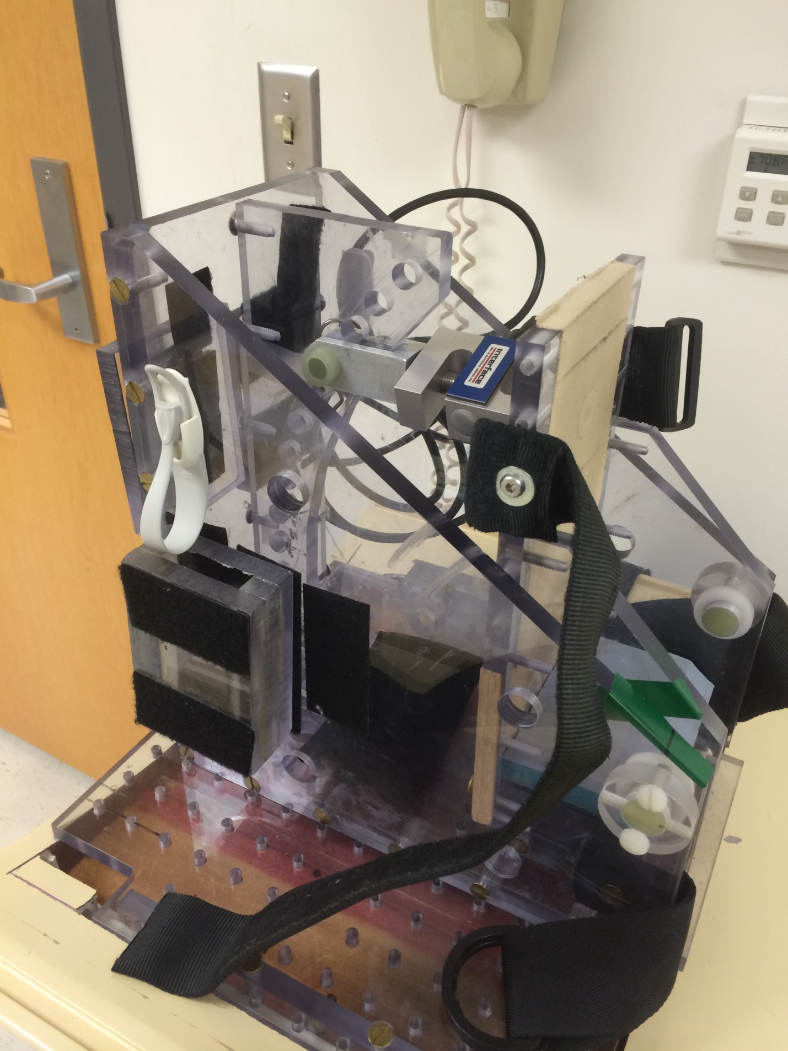

Force Transducer

Foot Pad

Extra Blocks

(4th Hole = 90°)

Angle Adjust

Foot Strap

Connector Cable

Cable Holder

**Figure 2: Components of the Foot Exercise Device (FED).**

# PATIENT BED SET-UP

The patient bed should be prepared in the muscle physiology lab prior to moving the equipment to the MRI room.

1. Use the hex wrench to attach the FED to the center of the patient bed with MR safe bolts. (Figure 3).
   1. ***NOTE:*** The hex wrench should NOT enter the magnet room. Check that it is not on the patient bed prior to leaving the muscle physiology lab!
2. Set the foot plate on the FED to the appropriate ankle angle.
   1. Foot plate pin positions are spaced in 5 degree increments starting at a 75 degree angle in pin position 1.
   2. Figure 3 shows the FED positioned at a 90 degree angle (pin position 4).
3. Adjust the number of heel blocks on the FED to the appropriate number for the subject.
4. Assemble the force system equipment on the patient bed for transportation to the MRI.
5. Wheel the patient bed to the MRI room – the feet side of the table should enter the magnet room first.

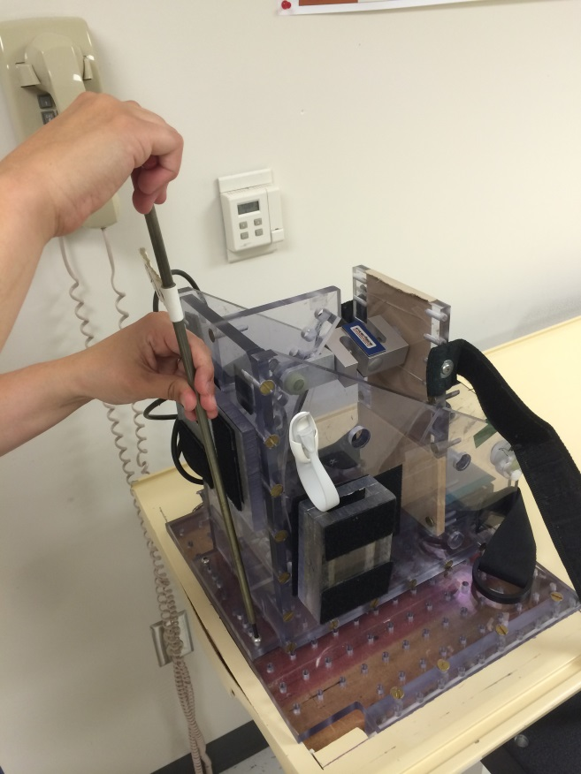

Bolt FED to table using the hex wrench

Make sure to screw in all four bolts

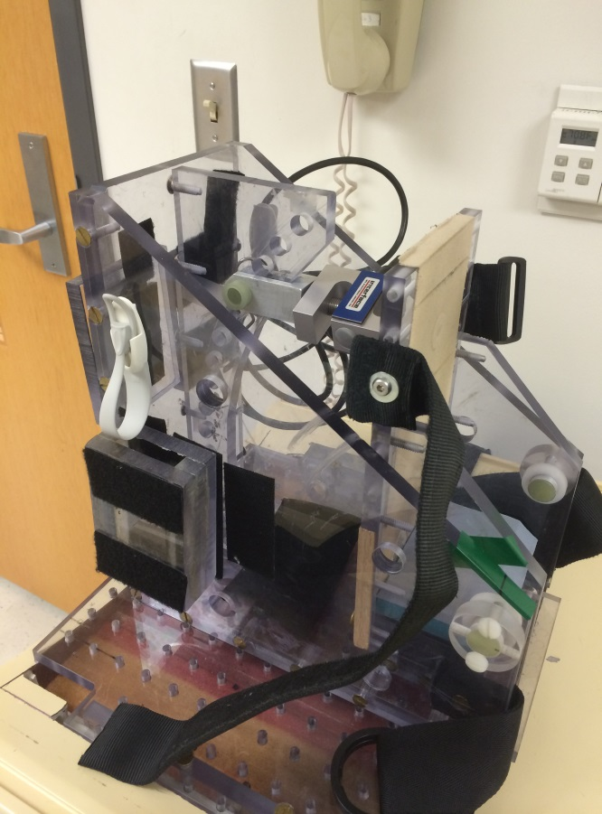

**Figure 3: Bolting the FED to the patient bed.**

# OUTSIDE THE MAGNET ROOM

MRI Computer

1. Select the appropriate MRI Patch.
   1. Patch must be applied before pulling over an exam card. Otherwise parameters that are patch-specific may default to incorrect values
   2. ***NOTE:*** For better performance on Release 5, the patch should be switched prior to landmarking the patient.
2. Start a new patient exam:
   1. Ask the MRI tech to check the subject’s MRI screening form
   2. Enter the scan number (e.g. DAMON_######)
   3. Enter the subject’s birth year (e.g. 01/01/####)
   4. Enter the subject’s body mass

Force Computer

1. Set-up the force system:
   1. Connect the 15V cable from the force box to the outside panel (Figure 4).
   2. Plug the force box into a power outlet.
   3. Switch the force box to the 15V supply.
      1. ***NOTE:*** The 15V power supply should only be used for the FED. The low-profile force transducers require a maximum 10V power supply.
   4. Open the Labview Force Program on the laptop. Additional testing of the force system can be completed once the FED has been connected to the panel in the magnet room (see “Magnet Room” instructions below).
      1. ***NOTE:*** See the Force System manual for instructions to set-up and debug the force program.

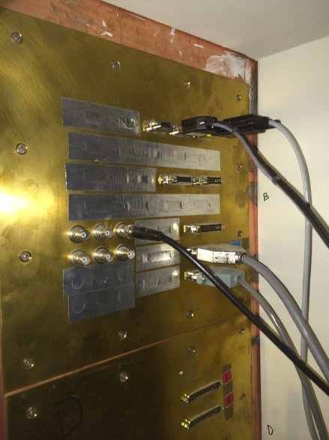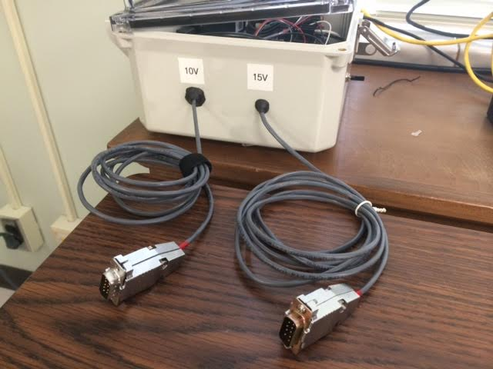

Run the proper 9 pin connector (15V for FED, 10V for all other transducers) down the back side of the desk and connect to the panel in the bottom corner outside the magnet.

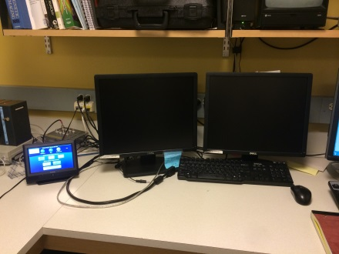

Cable drop in this corner

Connect here on panel

**Figure 4: Connect the force box to the magnet room.**

1. Configure the computer to display visual feedback from the force system to the subject in the magnet room (Figure 5):
   1. Connect the Audio/Visual output cable to the laptop.
   2. Select the video options on the Extron touch-screen:
      1. Video source device – “Aux/Laptop”
      2. Video output device – “Front Projector”
   3. Drag the force system program window to the *right* of the screen to extend the display to the front projector.
   4. Turn the power on the front projector.

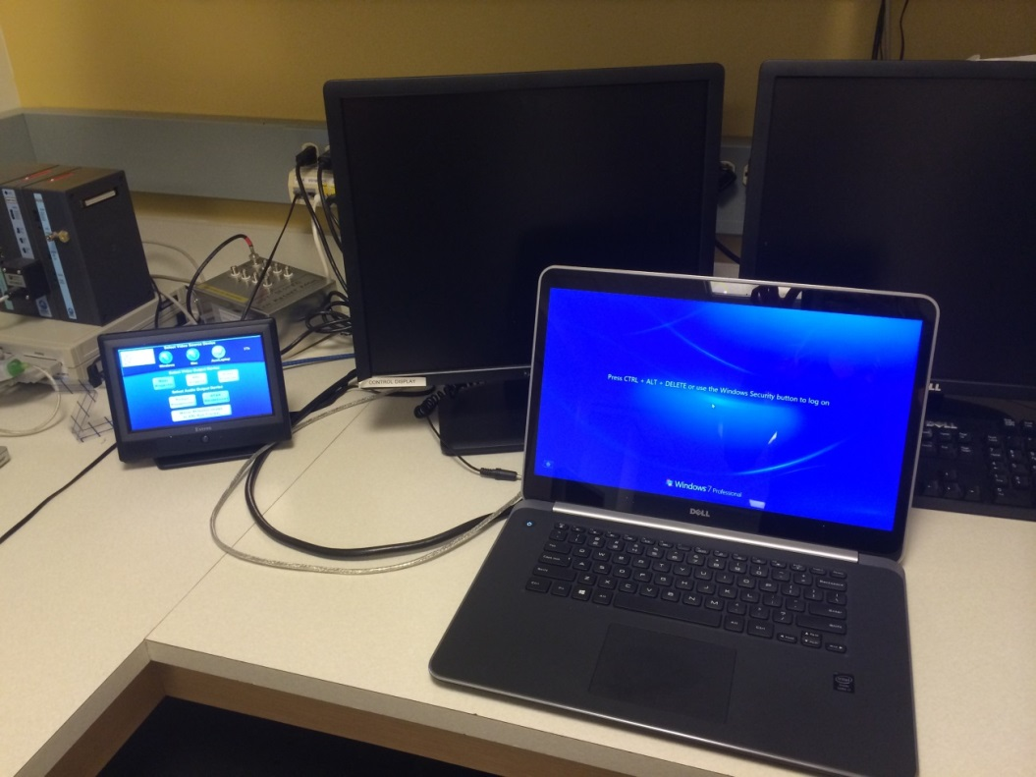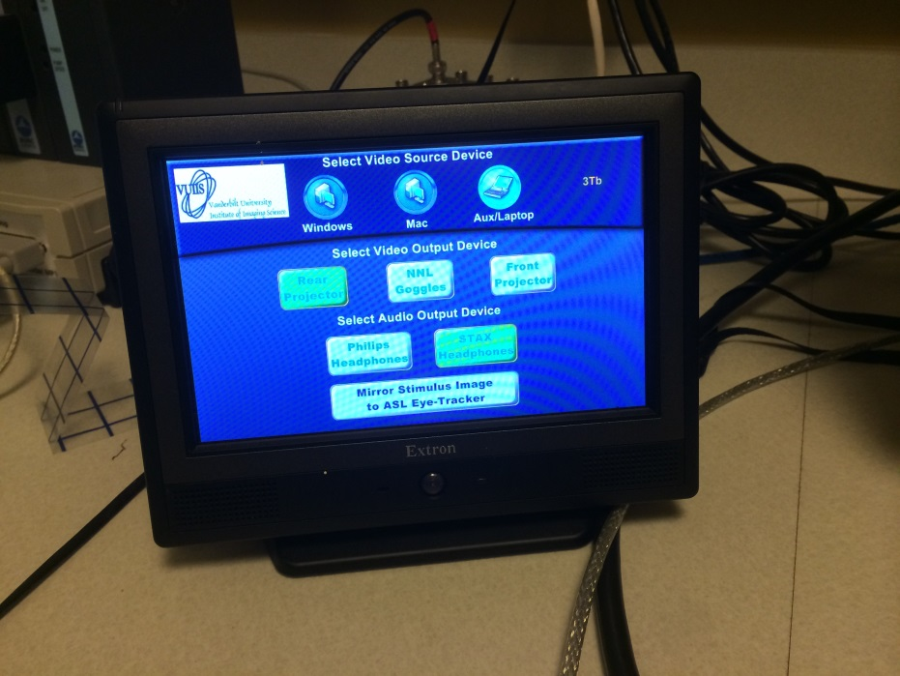

Extended display will show on the right monitor

**Figure 5: Connect the laptop to the aux/laptop video source and select the front projector video output to display visual force feedback during the scan.**

# MAGNET ROOM

Prior to Subject Arrival

1. Connect the patient bed to the scanner:
   1. Wheel the patient bed into the magnet room.
      1. ***NOTE:*** Check for metal on the bed prior to entering the magnet room!
   2. Remove the default patient bed and place on the floor to the side of the magnet.
   3. Place the muscle lab patient bed on the scanner – listen for it to lock onto the motor gantry.
   4. Slide the patient bed to the back of the magnet to connect the force system cable.
      1. ***NOTE:*** Check that the FED cable is clear of the patient bed tracks.
2. Connect the FED to the force system:
   1. Connect the extension cable to the FED cable.
   2. Unravel the extension cable and connect it to the panel opposite the 15V cable located outside the magnet room (see Figure 4 as reference to the outside panel).
      1. ***NOTE:*** Small metal screws in the connector will be attracted to the magnet. Hold onto the connector while unraveling the extension cable to prevent erratic movements of the cable.
   3. Slide the patient bed out of the bore of the magnet.
3. Prep the patient bed for the subject:
   1. Place the bottom of the coil on the patient bed - lock the coil in the track on the side of the patient bed (Figure 5 shows the placement of the knee coil).
   2. Line the bottom of the coil with a pillow case to avoid pinching the subject’s leg (Figure 5).
   3. Put the thick foam pads on the patient bed (Figure 5).
      1. ***NOTE:*** A thinner body pad can be used if the subject’s heart is much higher than the body part of interest, but the subject’s comfort is a top priority. (This is a concern for flow measurements.)
   4. Place a sheet and a pillow over the foam pads (Figure 5).

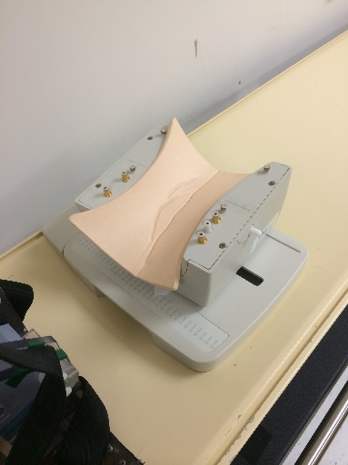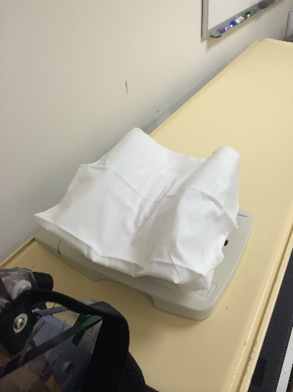

1. Positon coil in MR bed track

2. Place sheet over bottom half of coil

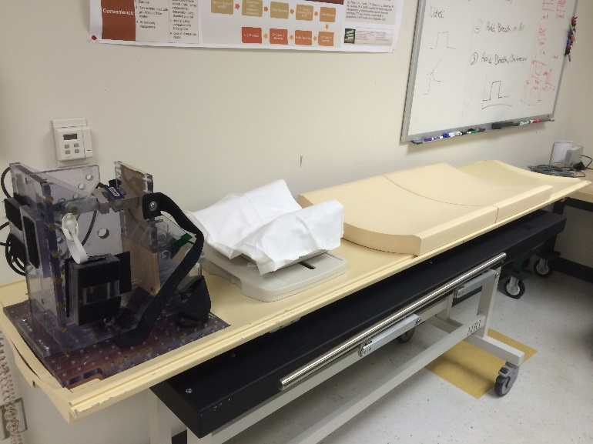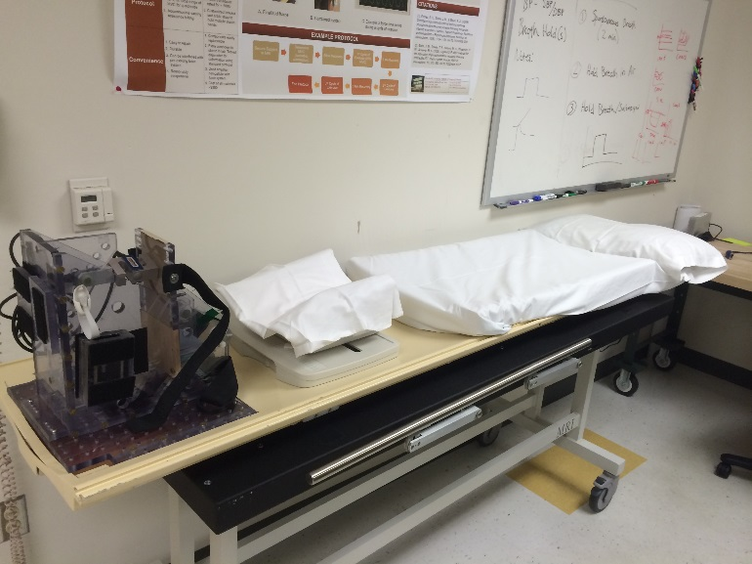

3. Place foam pads on table

4. Cover pads and pillow with sheets

**Figure 5: Prepare the Patient Bed.**

Subject Prep

1. Lower the patient bed to allow the subject to easily lay on the bed.
   1. ***NOTE:*** Before raising the bed, have subject lay down and place foot in the FED so you can check if the correct portion of the leg will be in the isocenter of the coil. If needed, have the subject stand up so you can adjust the coil.
2. Raise the bed back to the scanner height to continue prepping the subject for the scan.
3. With the subject laying down in position, secure the subject’s foot in the FED – place foam pads under the top and ankle straps to improve the subject’s comfort (Figure 6). If needed additional foam pads can be placed under the subject’s heel.
   1. ***NOTE:*** Check that the subject’s foot is in a straight line with his/her body. If needed, adjust the subject’s hip position to achieve a straight line of action with the FED.
   2. ***NOTE:*** If subject is not wearing socks, provide them with booties.
4. Place a rolled towel under the subject’s opposite foot so that it is level with the foot in the FED (Figure 6). Remind the subject that he/she may need to adjust the position of this foot to fit into the bore of the magnet.

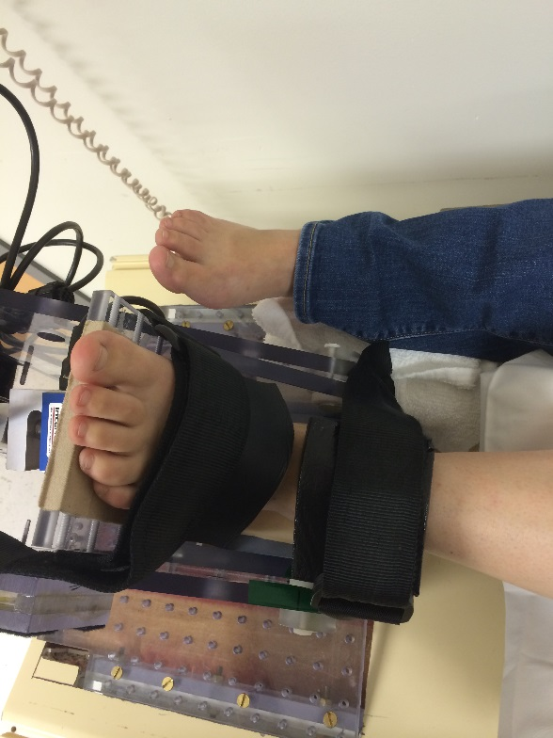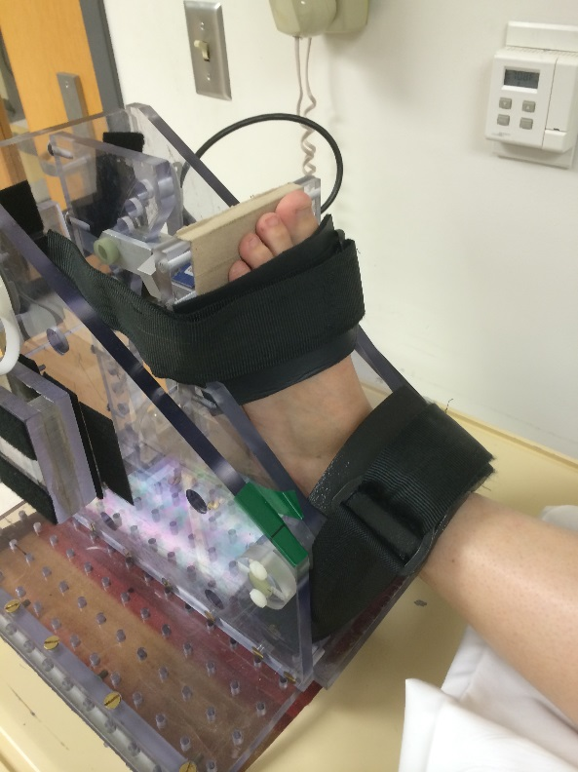

Strap foot in cushioning with pads under the straps for comfort

Place towel under opposite foot

**Figure 6: Secure the subject's foot in the FED and add padding to reduce discomfort. (During testing, subject should be wearing socks or booties.)**

1. Identify the area of interest (e.g. widest cross-section of the tibialis anterior):
   1. Ask the subject to contract the muscle.
   2. Palpate the muscle to identify the widest cross-section of the muscle (Figure 7).
   3. Reposition the isocenter of the coil coincident with the widest cross-section of the muscle (Figure 7).
   4. Wrap the pillow case around the subject’s leg.
   5. Secure the coil around the subject’s leg (Figure 7).
      1. ***NOTE:*** The coil cable should exit towards the subject’s head.
2. Connect the coil cable to the scanner.

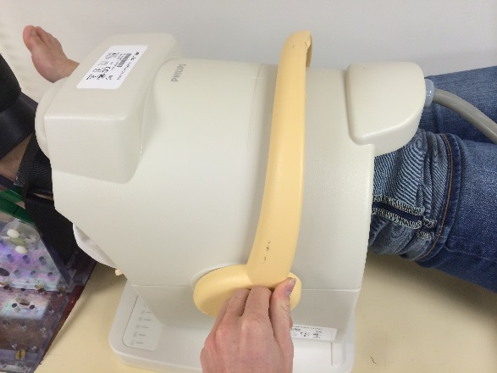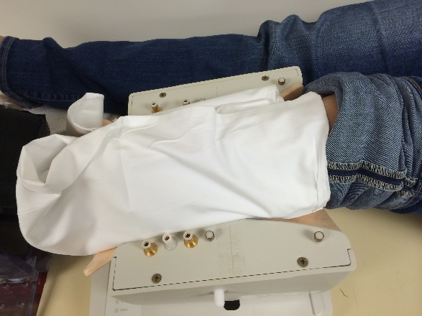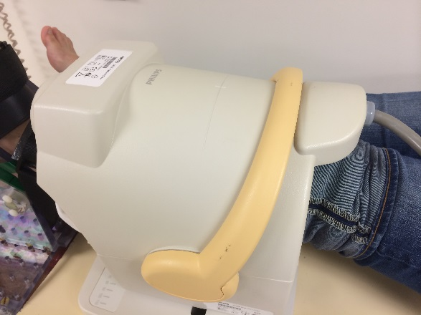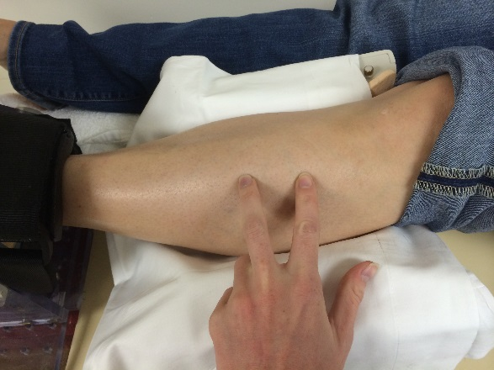

Palpate muscle belly to find largest cross sectional area

Align with the isocenter of the coil indicated by small lines

Place top half of coil making sure the Phillips logo faces the subject

Close coil latch by pulling handle down toward subject

**Figure 7: Identify the widest cross sectional area of the muscle of interest and secure the coil around the subject’s leg.**

* 1. ***NOTE:*** The number of pins in the coil cable connector should match the port on the scanner.

1. Place foam supports to improve the subject’s comfort:
   1. Small foam pads should be packed into the coil to reduce the movement of the subject’s leg (Figure 8).
   2. Larger wedge foams should be placed under the subject’s thigh to prevent hyperextension of the knee and, when necessary, such that the subject’s leg is at heart level (Figure 8). A second foam wedge should be placed under the contralateral leg to improve the subject’s comfort.
      1. ***NOTE:*** The foam support should be placed superior to the subject’s knee to reduce pressure on the popliteal artery with the sharpest angle toward the subject’s head.
   3. Slide a plastic arm support under the foam on the contralateral side of the subject to help hold his/her arm on the patient bed.
   4. Ask the subject if he/she is experiencing any discomfort or would like a blanket.
2. Give the subject a set of earplugs, the headphones with the audio cable connected to the scanner, and the call button.
3. Landmark the isocenter of the coil:
   1. Turn on the laser marker on the MRI scanner control panel.
   2. Slide the patient bed such that the laser marker is located over the isocenter of the coil – marked as a cross on the top of the coil – or over the area of interest in the leg.
   3. Save the location of the laser marker.
   4. Slowly slide the patient bed into the bore of the magnet. The bed will pause when the landmark is in the center of the magnet.
4. Turn off the magnet room lights.
5. Ask the subject if he/she has any difficulty seeing the visual feedback projected on the scanner. Adjust the focus and position of the projector as needed.
6. Close the magnet room door to start the scan.

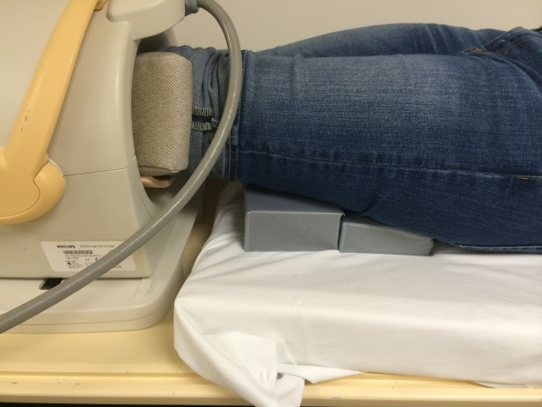

Positon foam under leg so it rests at heart level

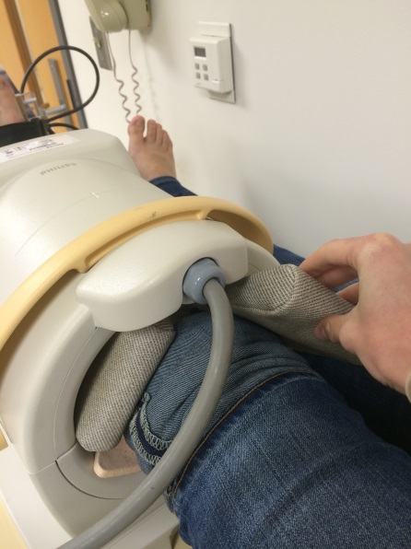

Pack foam in for comfort and leg stabilization

**Figure 8: Place foam supports into the coil and under the subject's leg to reduce motion and to position the leg at heart level.**